VOLUMES:

VOLUMES:
- Problems that K8s volumes aims to address:
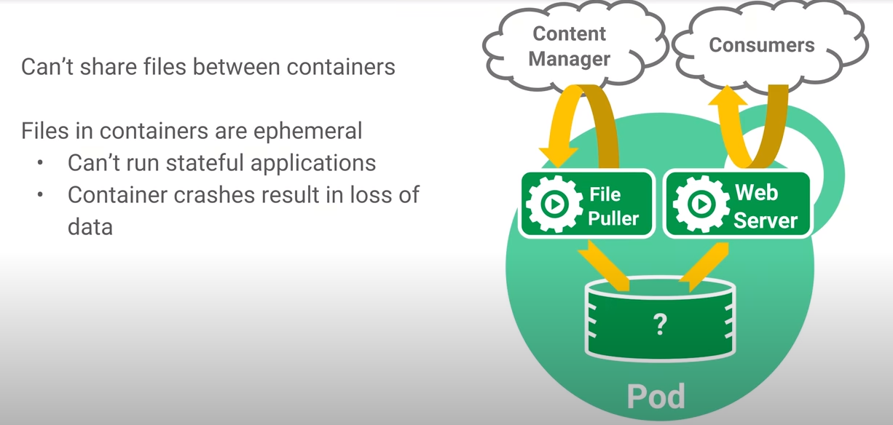
- Volumes are used to share the file system of host machine with the files ystem inside a container.

- Why we need volumes:-
- Suppose we have a postgress container that creates some data.
- When the container is deleted, all the data created by the container is also gone.

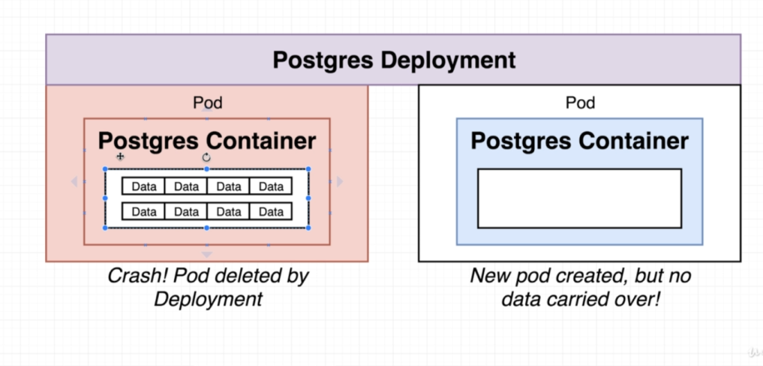
- We can solve this using Volumes
- Using volumes we can have persistent file system on the machine that can be accessed by the database container.
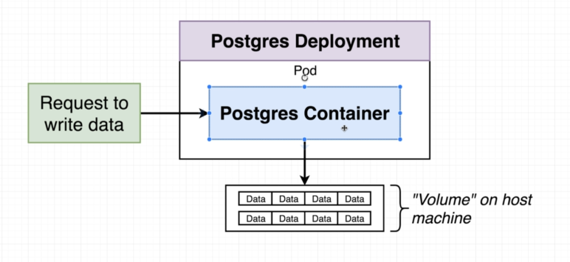
- So the data base won't be writing any data inside the container, but to the file system outside the container.
- And when a Pod is deleted and new one is created then the new Pod gets associated to the same file system to ensure data persistence .
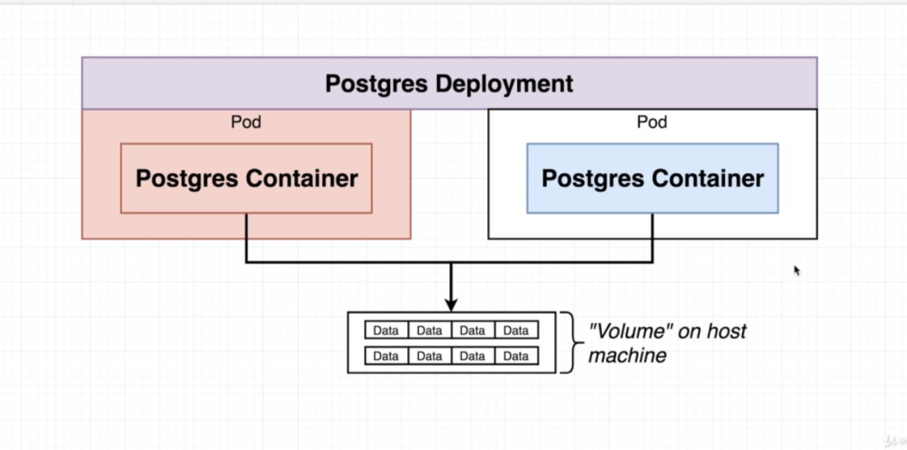
- VOLUMES in Kubernetes:

- Volumes in Kubernetes vs in Docker:
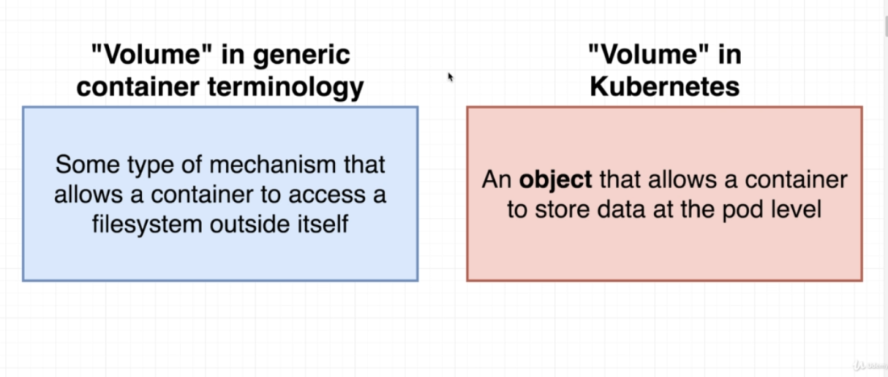

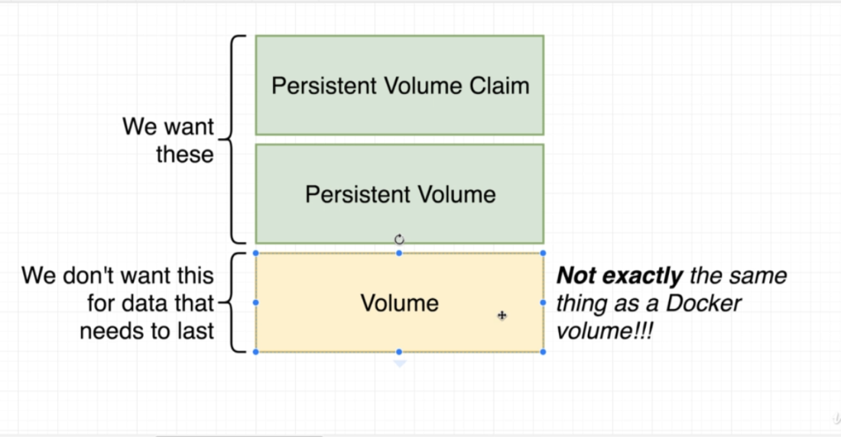
- We can create a config file in Kubernetes to create a volume.
- In Kubernetes, the Volume is data store/directory (with some data in it) that belongs to a particular Pod.
- Any container running on that Pod, has access to that data store.
- This data store is created on the machine on which the POD is running.
- So if the container is destroyed and recreated, then it will have the access to the same data store.

- But this volume gets deleted if the entire Pod is deleted.
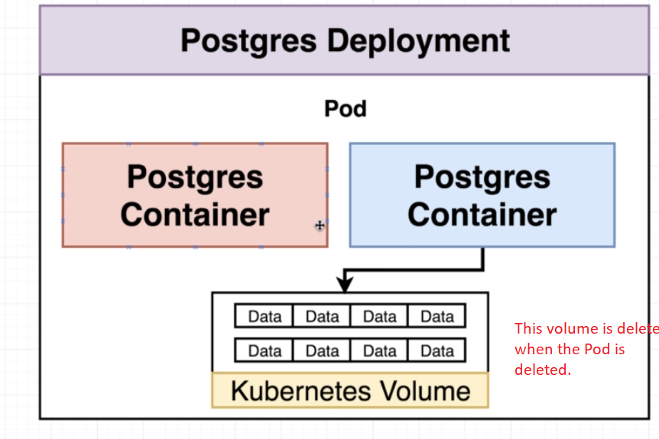
- So we need to use something called as a Persistent Volume

- Volumes Vs Persistence Volume:
- Persistence volume is long term durable storage that is not associated with any container or Pod.
- So it remains persisted even if the Pod gets deleted or restarted.
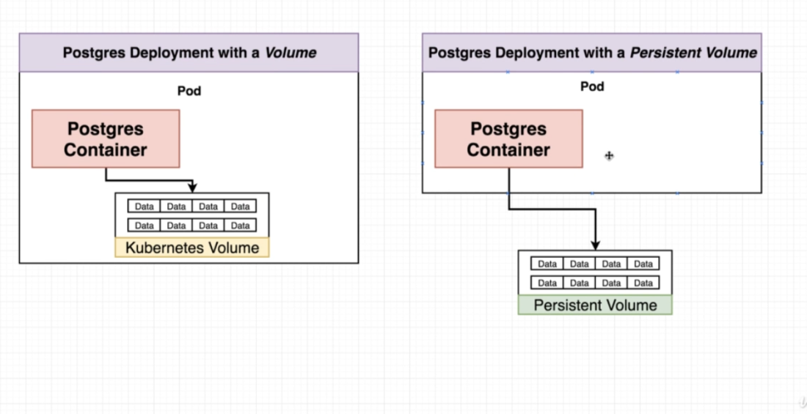

- Persistence Volume Vs Persistence Volume Claim
- PV is a the pre-provisioned storage in the cluster.
- PVC is just a request for storage by the user/dev for some storage.
- Persistence Volume claim is like an advertisement that allows the Pods to choose form some pre advertised set of volume space.
- 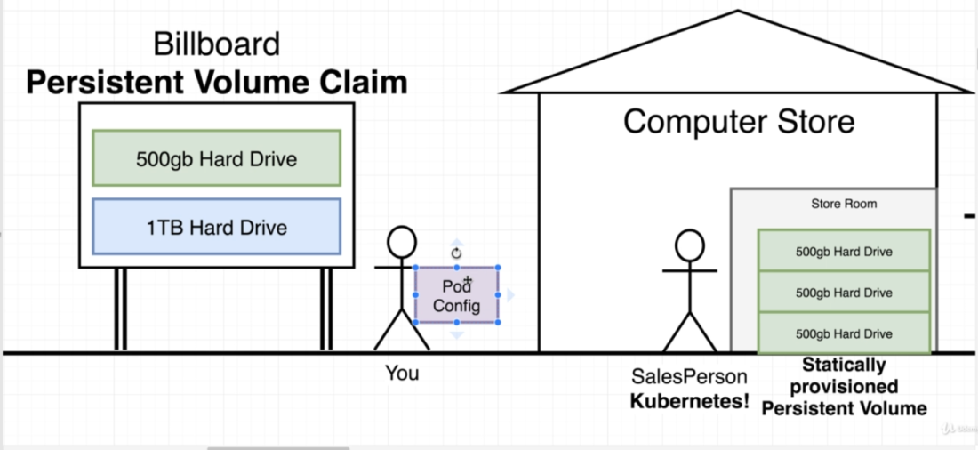

- If K8s does not have the volume that the user asked for, then I will create that Volume on the fly and provide it to the pod.
- Volume claim is not an actual instance of storage.
- We attach the claim to a Pod config.
- This Pod config is then applied to the K8.
- K8 will check the claim and try to find a statically provisioned or a dynamically provisioned volume.

- Config file for Persistence Volume.
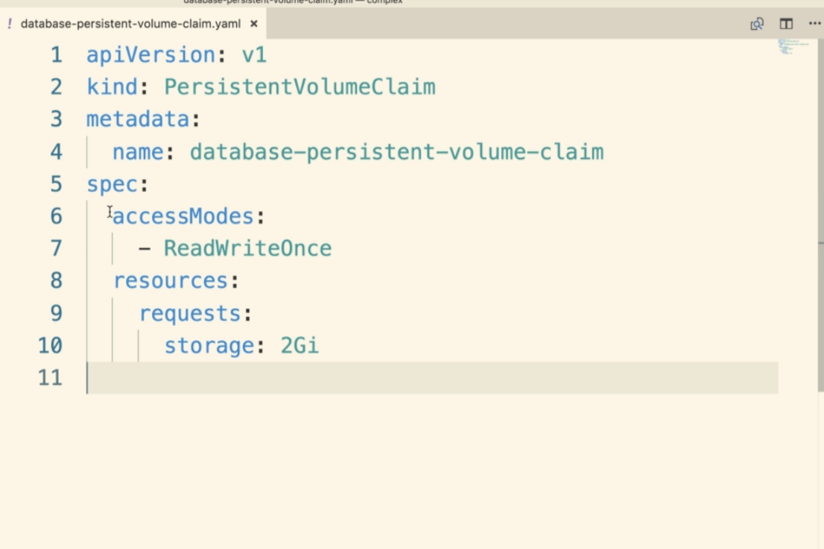

- Access Modes:
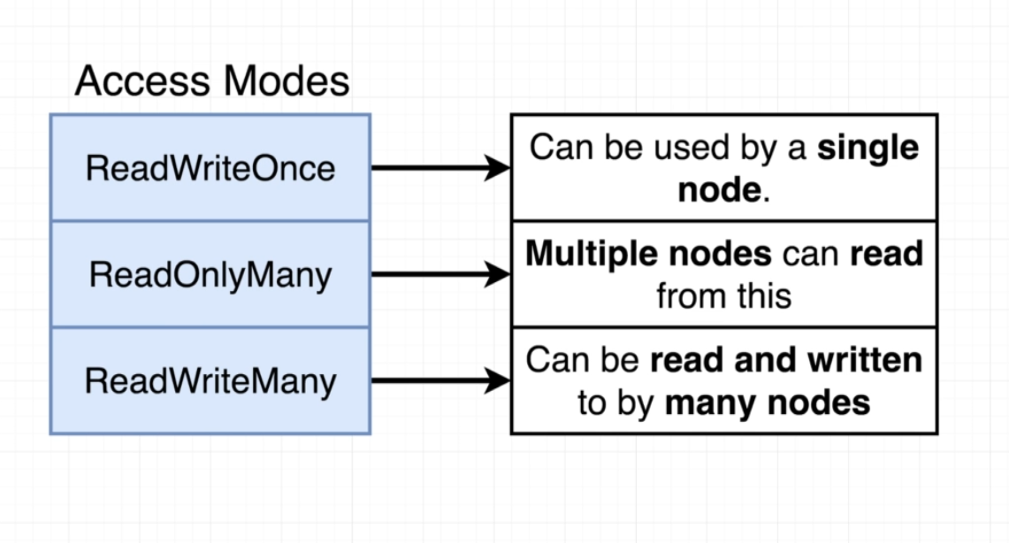
ReadWriteOnce: Only a single node can use this volume (both Read and Write) at a given time
ReadOnlyMany: Many nodes can (only) read the volume at a given time.
ReadWriteMany: Many nodes can both read and write the persistence volume at a given time.

- StorageClassName
- When we request for some amount of storage in our local environment it will take a slice of the storage from the host machine.
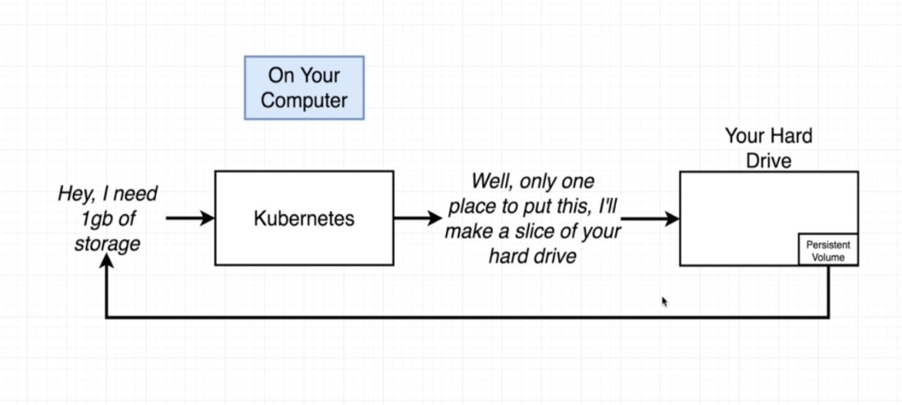

- So in local, it will be using the default minikube host path provisioner
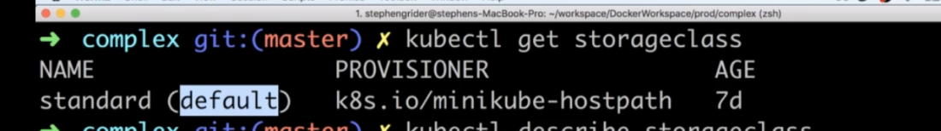
- In case of Production environment where its using some cloud platform, then it will automatically provided for us.
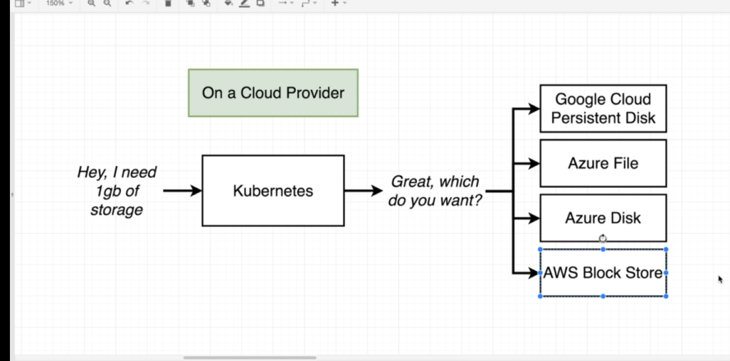
g) Associating Pod to the PVC
- We can do this inside the 'Spec' section of the pod config.
- 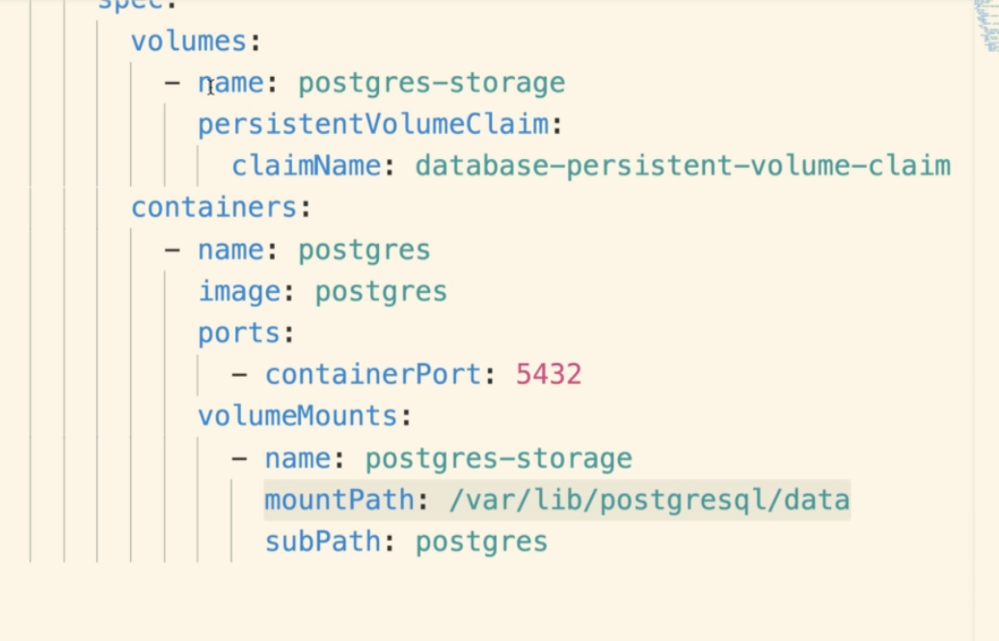

Volume types:
- At its core, a Volume is just a directory, with some data it it.
- How this volume/directory comes to be, the medium that backs it and the contents of it are determined by the particular volume type being used.
- A Process inside a container sees the file system view composed from their docker image and volume.
- The docker image is at the root of the filesystem hierarchy and any volumes are mounted at the specific paths within the image.
- Volumes can’t be mounted onto other volumes or have hard links to other volumes.
- Each container in a POD must independently specify where to to the mount the volume.

Types:
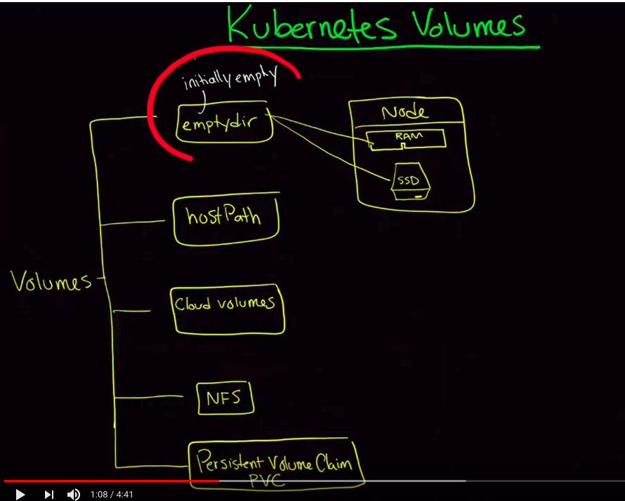

a) empty-dir:
- contents are initially empty.
- nodes can store the contents that we want in a volume.
- This volume can be in a RAM or persistence storage.
- This storage runs on the Node. So its good as long the node is running.
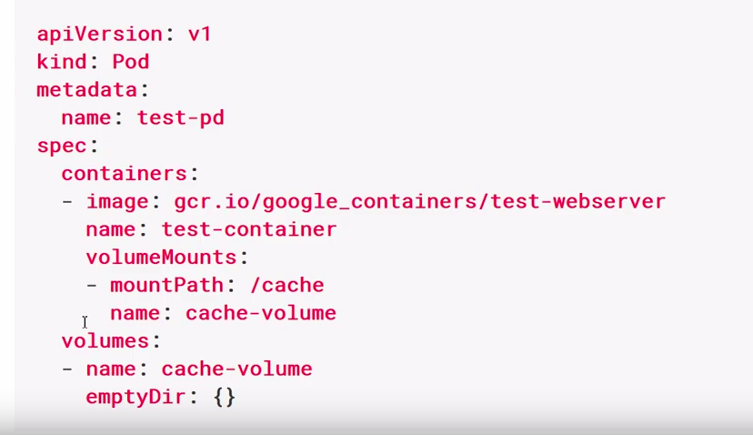

- Volume section will have the type of volume to be used with the pod.
- VolumeMount section will tell where to mount that volume inside that container.

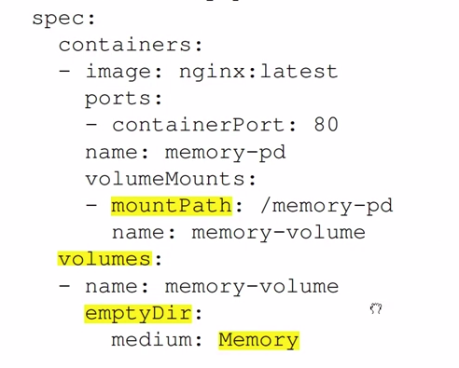

b) Hostpath:
- Connected the same way as empty dir.
- But we use it when we don’t want our path to be empty initially.
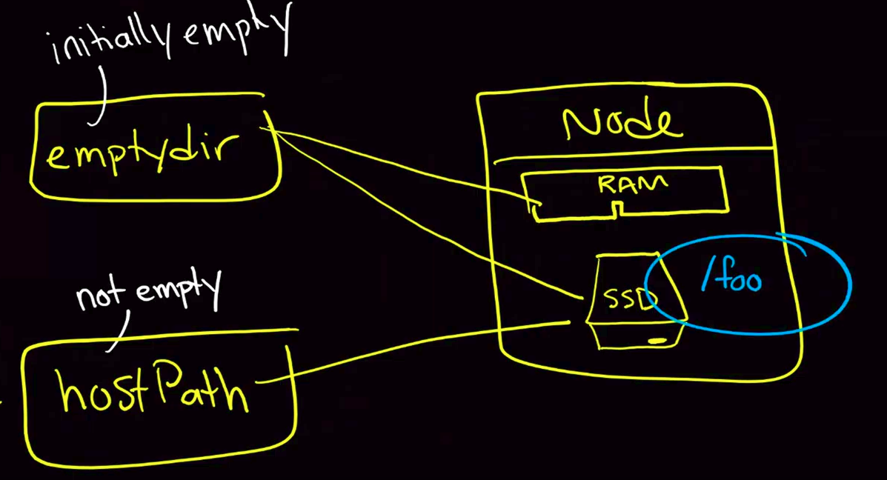

c) Cloud Volumes: (GCE, AWS etc)
- We create yaml files to tell the POD to connect to some of the providers like elastic search, etc.
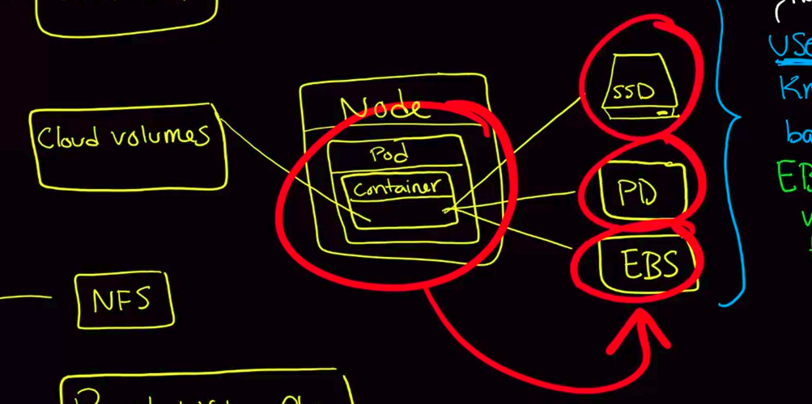

Example:
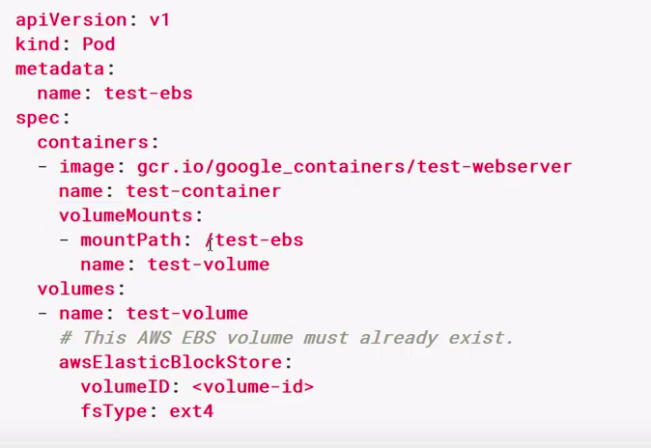
- Problem here is the the user have to know about the VolumeID and FsType and other low level details which may not be useful.
- So we use PVC to solve this problem by providing a consistent way of dealing with different storage providers.

d) PVC:
- Node is connected to through a series of abstractions that give access to underlying cloud provided volume.
- User can provide this abstraction without providing Volume ID or Nfs details etc.
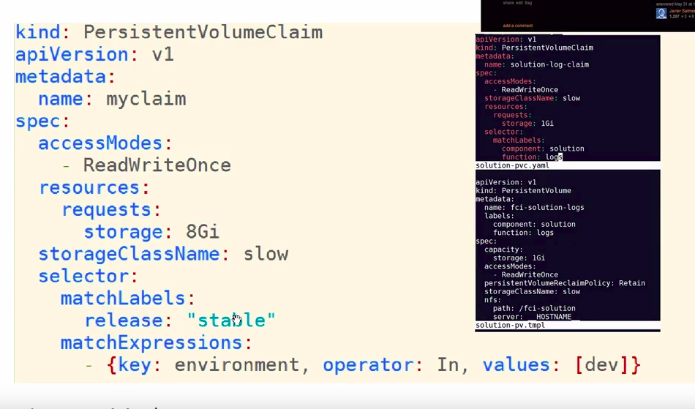

Volume life cycle:

1. Provisioning:
- when someone (admin) creates the storage.
- Storage can be block, object, etc.
- Provision can be static or dynamic:
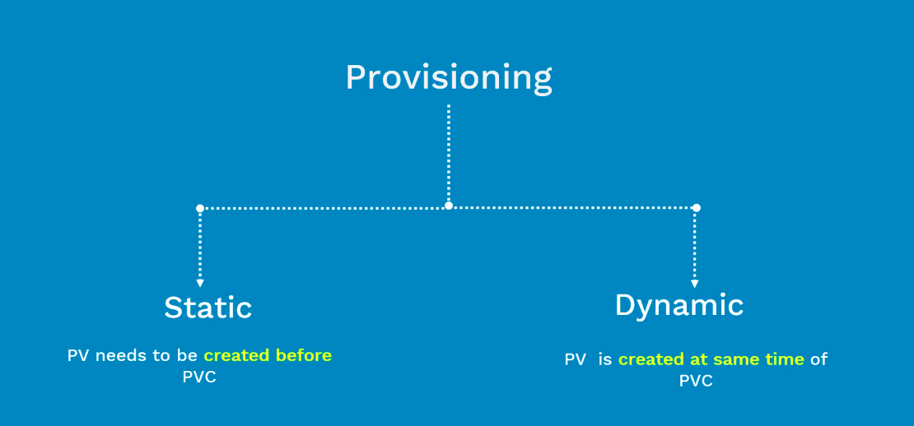

- For dynamic storage to happen, we need to configure the default storage class inside k8.

Static Provisioning :

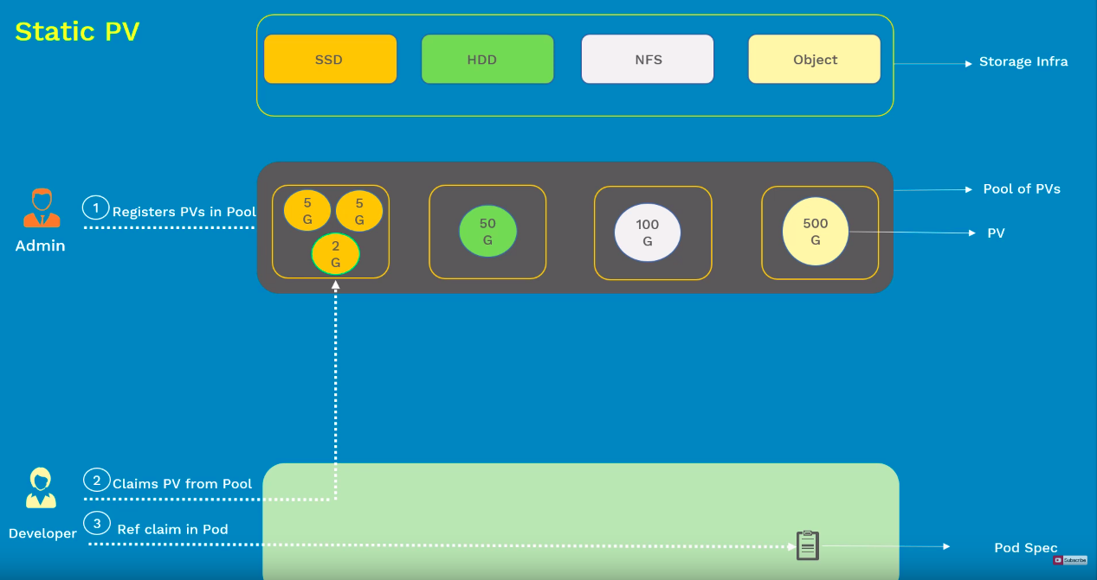

Dynamic Provisioning:
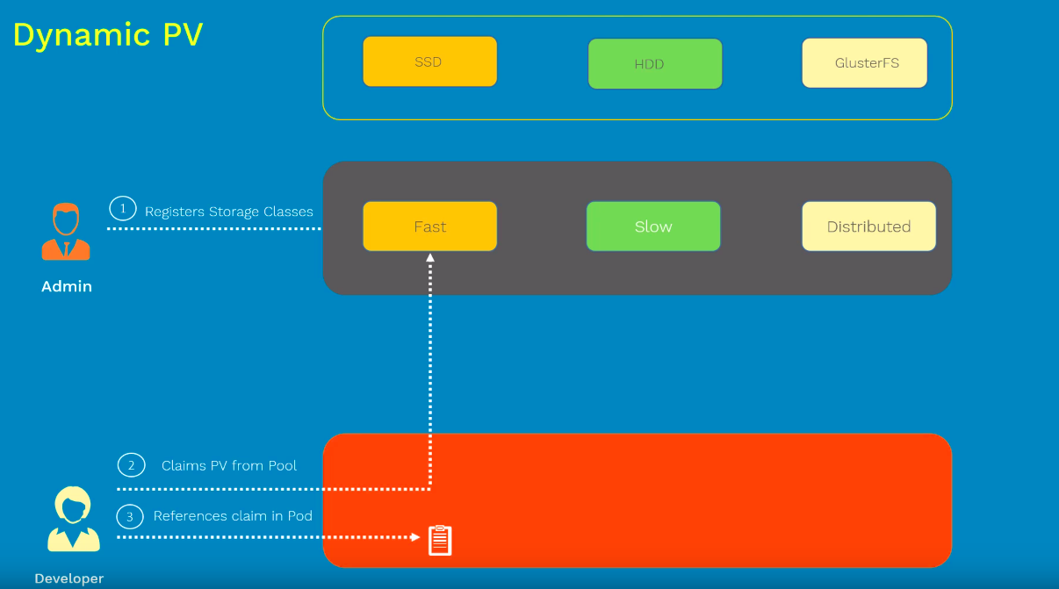

https://www.youtube.com/watch?v=qktFhjJmFhg
Start again after 10 minutes.

Persistance Volume:
- refers to the actual storage instance that is available for the application to use.
- Each persistence volume contains information about the storage it exposes and the connection information.
- Normally, cluster or storage admins create these pv objects (no the applications).
- Once these pv objects are created, they are available for use.
- If a application wants to use this pv storage, then must create a request for this storage.
- This is done by the pvc object.
- PVC objects contains information about the minimum requirements of storage that we need.
1. Minimum disk capacity.
2. Access modes.
- When the PCV object is created, Kubernetes takes the request and matches it with a available unboud PV. If found, then pv is bound to the PVC.
- Now this claim can be used by application developer.

- having a cluster/storage admin pre-provision all the storage volumes (pv) in advance can be cumbersome.
- Dynamic Provision and Storage classes can be used in this case. (this is feature unique to kubernetes)
- Here the cluster automatically creates a new piece of storage to fulfill a pvc request. This is mainly done with making an API request to the understand cloud provider which then attaches a storage to the cluster node a matter of seconds.

- To use dynamic provisioning, cluster/storage admin must first enable it by creating StorageClass objects.
- Storage class objects specifies parameters used for creating dynamic volumes like:
1) Volume plugin to be used for provisioning.
2) Parameters to be passed for the plugin.
- In order to use this dynamic provisioning, the application user can create a pvc and mention the storageclass they want to use.
- Now k8s will call the provisoner defined in the storage class to provision a new storage.
- Once provisioned, k8s will create a pv object and binds it with the users persistence volume claim.
- Dynamically provisoned volumes are created with a delete policy. It means once the pvc is deleted, the dynamically provisoned volume will automatically be deleted.
- Marking a storage class defualt, will always following dynamic provisioning of the volumes.

